Point de ventes :

 Les Planches :
https://www.google.com/maps/place//data=!4m2!3m1!1s0x47e5e1418cc66e61:0xea27690722a04499?sa=X&ved=1t:8290&ictx=111

 Vélorail de la Juine ;
https://www.google.com/maps/place//data=!4m2!3m1!1s0x47e5b534cc12337d:0x1b7c3235d985e32e?sa=X&ved=1t:8290&ictx=111

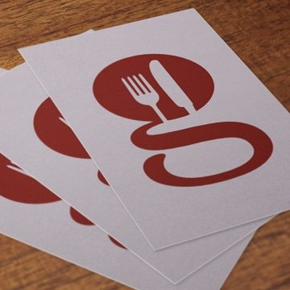 L’Atelier de Guill’home :
https://www.google.com/maps/place//data=!4m2!3m1!1s0x47e5c93a1502a48b:0x507b30523b58d36?sa=X&ved=1t:8290&ictx=111
 Domaine Malr :
https://maps.google.com/maps?hl=fr&gl=fr&um=1&ie=UTF-8&fb=1&sa=X&ftid=0x47e5b5001fd8951f:0x61146d0d8b2818e8
 Café de la paix Saclas :
https://maps.google.com/maps?hl=fr&gl=fr&um=1&ie=UTF-8&fb=1&sa=X&ftid=0x47e5b5953da0ada1:0x88363ca0774de77
 Boucherie Saclas :
https://www.google.com/maps/place//data=!4m2!3m1!1s0x47e5b5be13a1e16b:0xa7229cdca0c6432e?sa=X&ved=1t:8290&ictx=111
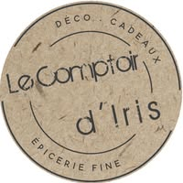 Comptoir d’Iris
https://www.google.com/maps/place//data=!4m2!3m1!1s0x47e44b54d0e5949f:0x829a53a621894b3c?sa=X&ved=1t:8290&ictx=111
 Repos de la Vallée :
https://www.google.com/maps/place//data=!4m2!3m1!1s0x47e5b6016cd10661:0xf801b7a11aaca150?sa=X&ved=1t:8290&ictx=111
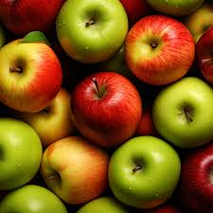 Le potager d’Ormoy :
https://www.google.com/maps/place//data=!4m2!3m1!1s0x47e5ca241b3dca2f:0xe07e72817fcb21f6?sa=X&ved=1t:8290&ictx=111
 Vauvert Ormoy la Rivière :
https://www.google.com/maps/place//data=!4m2!3m1!1s0x47e5ca2e4beeccf5:0x3bf4f4922a5d9d41?sa=X&ved=1t:8290&ictx=111
 Beer’s not Dead :
https://www.google.com/maps/place//data=!4m2!3m1!1s0x47e43305b3b14a7d:0xc29d46ac0ca497f?sa=X&ved=1t:8290&ictx=111
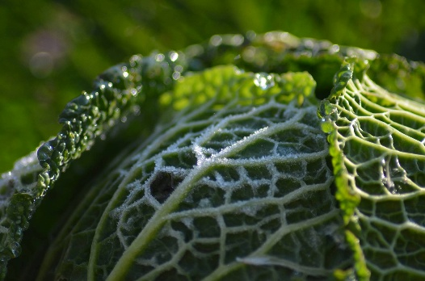 Les Jardins de la Marette :
https://www.google.com/maps/place//data=!4m2!3m1!1s0x47e5b57391d1b9db:0x42f1c6f2ed4be5fc?sa=X&ved=1t:8290&ictx=111
 Intercaves Itteville :
https://www.google.com/maps/place//data=!4m2!3m1!1s0x47e5c370d0eb89ff:0x178c275e9b98f3cb?sa=X&ved=1t:8290&ictx=111
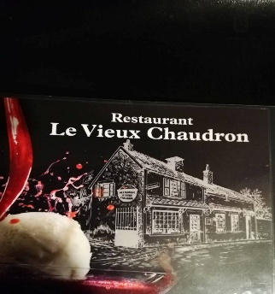 Le Vieux Chaudrons :
https://www.google.com/maps/place//data=!4m2!3m1!1s0x47e5c93a7036200d:0xf29616bac69c09ec?sa=X&ved=1t:8290&ictx=111
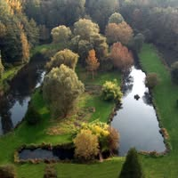 La source de l’Eclimont :
https://www.google.com/maps/place//data=!4m2!3m1!1s0x47e5b7f3d104745b:0x518e2fba3dd841d3?sa=X&ved=1t:8290&ictx=111

